

Bilal Walid Hamdanieh & Aurianne Mahfouz

Saturday, March 13, 2021

Structural Bioinformatics

With Dr. Joseph Rebehmed

Assignment Submission; Sonic Hedgehog Protein Scientific Illustration

This report will showcase the structure of Sonic Hedgehog Protein amino-terminal domain (Shh-N) in Chimera, and its Zinc ion ligand binding site structure to function analysis.

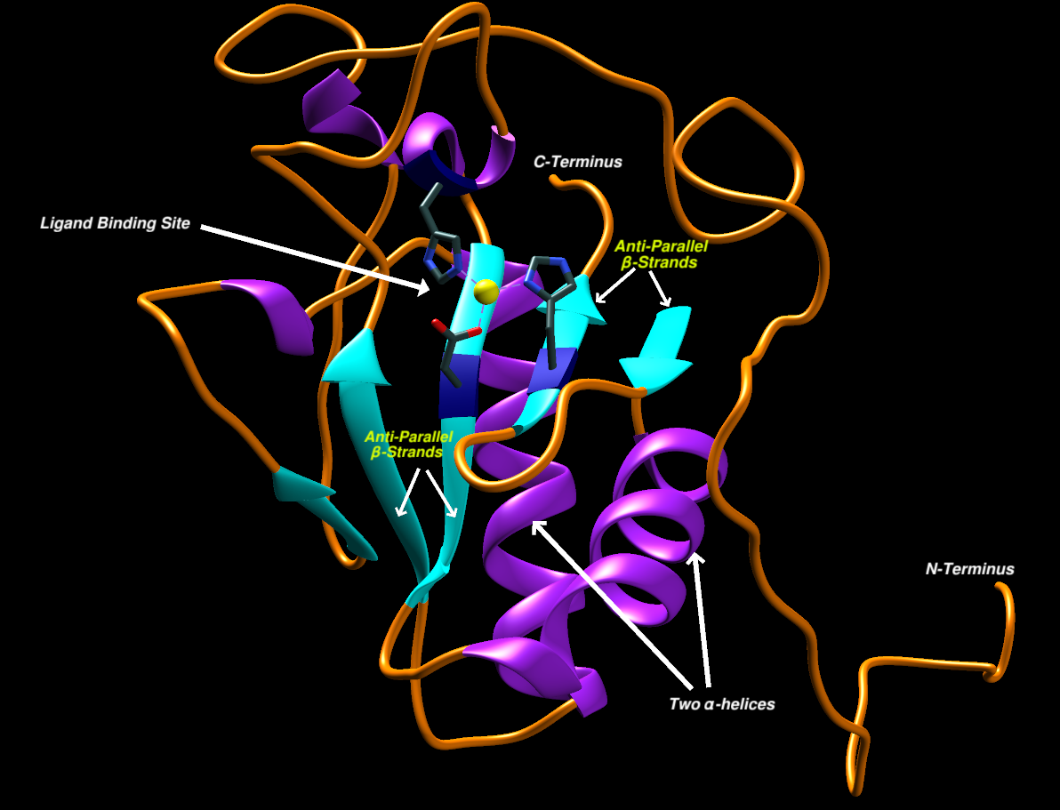

Figure : The Overall Structure of Sonic HedgeHog Protein.

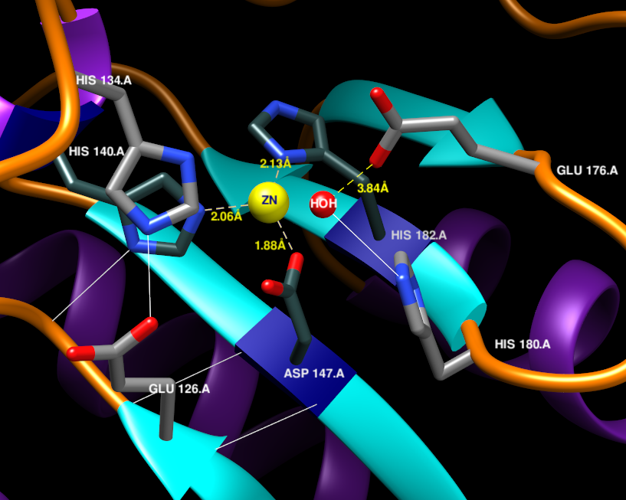

Figure 2: A view of the Zinc Ligand Coordination Site of Shh-N.

A- Biological Roles and Functions of Shh:

In vertebrates, SonicHedgehog plays an important role in regulating cell proliferation and patterning of the appendages in the early developmental stage, in addition to the development of many other organs and structures including the adrenal cortex, cerebellum, gastrointestinal tract, hair follicle, eye, face, teeth, kidney, long bone, lung, prostate, pancreas, pituitary gland and skeletal muscle. Secondly, the Shh protein is responsible for the specification of cell types within the neural tube. The different exposure levels and durations to Shh combine to appoint cells a unique neuronal identity. Shh also plays a major role in homeostasis as well as in regenerative response to injury in a number of organs including the airway, heart, and the bladder (As cited in Ho Lee et al., 2016 literature review[[3](https://dev.biologists.org/content/143/3/367)]). Some of these functions are possible due to many signaling pathways involving the Zn2+ ligand binding site that will be discussed in this report.

# B- Chimera Workflow and Structure to Function Analysis:

1. Loading the Sonic HedgeHog Protein Structure into Chimera.

PDB ID: 3M1N Biological Assembly 1

PDB File: 3m1n.pdb1.gz

> Download PDB File

> File > Open > Select File Path

1. Redefining the Secondary Structure of proteins according to Kabsch and Sander algorithm:

> ksdssp

Note: 2 of the β-strands were removed upon ksdssp correction

Note: The Locations of the residues are all 1 location less than the documented research (an amino-acid is missing in the loaded structure).

1. Previous Research shows that the Core of the Shh-N is composed of an α + β sandwich that consists of two α-helices, a 6 stranded mixed β-sheet and two-stranded anti-parallel β-sheet. In Figure 2, to highlight these structures we (1) color the ribbons orange, (2) the β-sheets as cyan, and (3) the helices purple[[1](https://www.nature.com/articles/378212a0)].

> color orange > color cyan strand > color purple helix => color by element

1. The catalytic site containing a Zinc2+ ligand of Shh-N bears very close structural resemblance to Zinc hydrolazes, such as D,D-carboxypeptidase. The Zn2+ ion is coordinated by 3 amino-acid residues His-140, Asp-147, and His-182[[1](https://www.nature.com/articles/378212a0)].It also appears that Glu 126, His 134, Glu-176, and His-180 are essential for the catalysis reactions[[1](https://www.nature.com/articles/378212a0),[2](https://www.pnas.org/content/96/20/10992)].

- Highlighting the Zn2+ coordinating residues:

> select : 140.A,147.A, 182.A

=> Actions => Label => Residue => Name + indicator

=> Actions => Color => All Options => Check Only Residue Labels => Color White

=> Actions => Color => All Options => Check Only Ribbons => Color Navy Blue

=> Actions => Color => All Options => Atoms/Bonds => Dark Slate Grey

=> Recolor Nitrogen and Oxygen Atoms as Blue and Red respectively

=> Action => Ribbon => Edged => deselect

- Highlighting the Ligand Zinc Ion:

> select Zn

=> Action => Label => Name

=> Action => Color => Yellow

=> All Options => Atom Labels => Navy Blue => deselect

- Highlighting the essential residues for catalysis:

> select : 126.A,134.A,176.A,180.A

=> Action => Label => Residue => Name + indicator

=> Action => Color => Residue Label => White

=> deselect

1. Then, in search for the Hydrogen Bonds, we see 2 H-bonds between the backbone of the residues Glu-126 and Asp-147 that are part of anti-parallel β-strands. Another Hydrogen bond is seen between His-134 NE2 and Glu-126 OE2.

> select : 140.A,147.A,182.A,126.A,134.A,176.A,180.A | Zn

=> Tools => Structural Analysis => FindHBonds => Only find H-bonds with both ends selected => deselect

1. In order to keep the Structure clear, we only select the atoms of the side chains of the latter 7 residues capable of Hydrogen bonding (Nitrogen and Oxygen), and we search for these hydrogen bonds.

=> Select Manually only Nitrogen and Oxygen Atoms on the latter 7 residues

=> Tools => Structural Analysis => FindHBonds => Show endpoint residue if hidden => Only find H-bonds with at least one end selected => keep current Hydrogen Bonds

There appears to be a Hydrogen bond between His-180 and a Water molecule directly situated above the Active Site which is key to the protein-enzymatic activity; by protonating the negatively charged Glu-177[[2](https://www.pnas.org/content/96/20/10992)].

- Make the water molecule bigger and label:

=> Select the Water molecule => Atoms and Bonds => balls and Sticks

=> Action => Label => Residue => Name

=> Action => Color => Residue Label => White => deselect

1. To further understand the structure of the catalytic site, the distances between His-140, Asp-147, and His-182 and the Zinc ion are calculated to be 2.06A, 1.88A, 2.13A respectively, and the distance between HOH and Glu-177 to be 3.84A. This alignment allows Shh active site to be a very good zinc hydrolase[[1](https://www.nature.com/articles/378212a0)].

=> Tools => Structural Analysis => Distances => Select the atoms manually and calculate the distances.

1. As this review only covers the structural analysis of the Zinc ligand, we clean the structure from any other Atoms and Side chains that are not included in the Ligand interaction. Finally, set the Labels as Bold and finalize the figures needed.